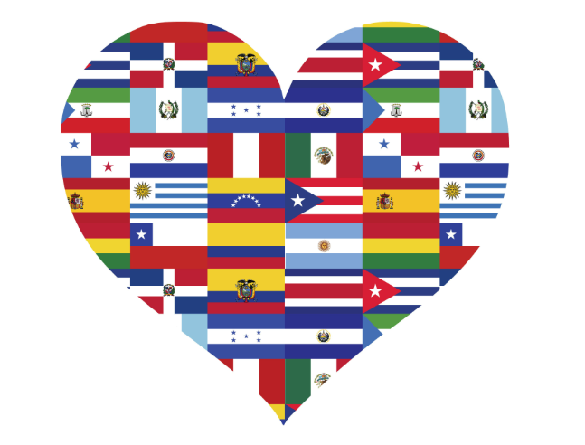
| (206) 555‐0100 | info@thephone-company.com
www.thephone-company.com
National Hispanic Heritage Month celebrates the contributions of Americans tracing their roots to Spain, Mexico, Central America, South America and the Spanish-speaking nations of the Caribbean.
In 1968, Congress set aside a week for this observance and two decades later expanded it to a month stretching from September 15 to October 15.
The timing is historically significant as September 15 is the anniversary of independence in Costa Rica, El Salvador, Guatemala, Honduras and Nicaragua. The designated period is also a nod to those from Mexico and Chile, which celebrate their independence September 16 and September 18, respectively.
The History of
Hispanic Heritage Month
Use icons to add visual interest  Insert some icons here to make your points. To insert a new on, go to the Insert ribbon and select icons. Scroll through the Microsoft built in icons and choose the one you want.finding the Icons  To change the icon, select it, then do a right mouse click. Choose “Change Graphic” from the menu. Select From Icons to update to a different Microsoft built in icon.  You can change the colour of the icon to suite, then drag and drop it in place. |  | Make It Yours  To get started right away, just select any placeholder text (such as this) and start typing to replace it with your own.  To easily customize the look of this brochure, on the Design tab of the ribbon, check out the Themes, Colors, and Fonts galleries.  No problem! The Themes, Colors, and Fonts galleries give you the option to add your own. |  | 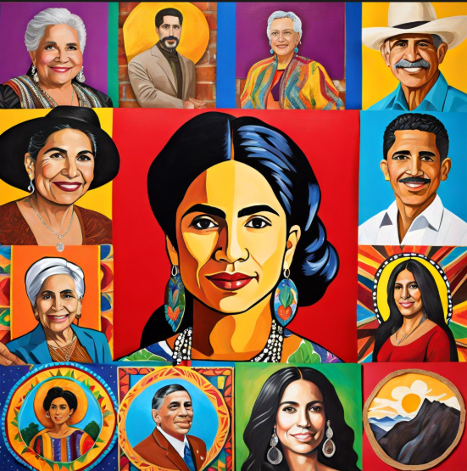
10. Rigoberta Menchú: Nobel Peace Prize winner and indigenous rights activist.
11. Oscar Hijuelos: Pulitzer Prize-winning author of The Mambo Kings Play Songs of Love.
12. Rita Moreno: EGOT winner, breaking barriers in film and TV.
13. John Ortiz: Actor and advocate for Latino representation.
14. Luis Valdez: Father of Chicano theater, founder of El Teatro Campesino.
15. Benjamin Bratt: Actor and activist for indigenous rights.
These individuals didn’t just succeed; they paved the way for the next generation.
Trailblazing Hispanic Figures Who Shaped History
Here are 15 figures who redefined what it means to be American.
1. Sonia Sotomayor: First Hispanic Supreme Court Justice.
2. Ellen Ochoa: First Hispanic woman in space.
3. Cesar Chavez: Labor leader and civil rights activist who co-founded the United Farm Workers.
4. Roberto Clemente: Baseball legend and humanitarian who died saving others.
5. Sylvia Mendez: Civil rights activist whose lawsuit desegregated California schools, paving the way for Brown v. Board.
6. Dolores Huerta: Co-founder of the United Farm Workers and labor leader.
7. Julian Castro: Former HUD Secretary and presidential candidate.
8. Lin-Manuel Miranda: Creator of Hamilton and In the Heights, revolutionizing Broadway.
9. Sonia Manzano: “Maria” on Sesame Street, a role that inspired millions of Latino children.
DID YOU KNOW?
The term “Hispanic” refers to people from Spanish-speaking countries, while “Latino” refers to those from Latin America. They overlap, but they aren’t identical!
One of the biggest misconceptions is that “Hispanic” equals “Mexican.” While Mexico has the largest Hispanic population in the U.S., the Hispanic diaspora is a kaleidoscope of cultures, languages, and traditions.
DID YOU KNOW?
70.1 million is the Hispanic population of the United States as of July 1, 2025, making it the nation’s largest racial or ethnic minority — 21% of the total population.
DID YOU KNOW?
16 is the number of states with 1 million or more Hispanic residents in 2025 — Arizona, California, Colorado, Florida, Georgia, Illinois, Massachusetts, Nevada, New Jersey, New Mexico, New York, North Carolina, Pennsylvania, Texas, Virginia and Washington.
DID YOU KNOW?
Over 8% (8.4) or 495 thousand (495,822) businesses in the United States were Hispanic owned in 2023.

